1. PREPROCESSING OF DATA USING WEKA

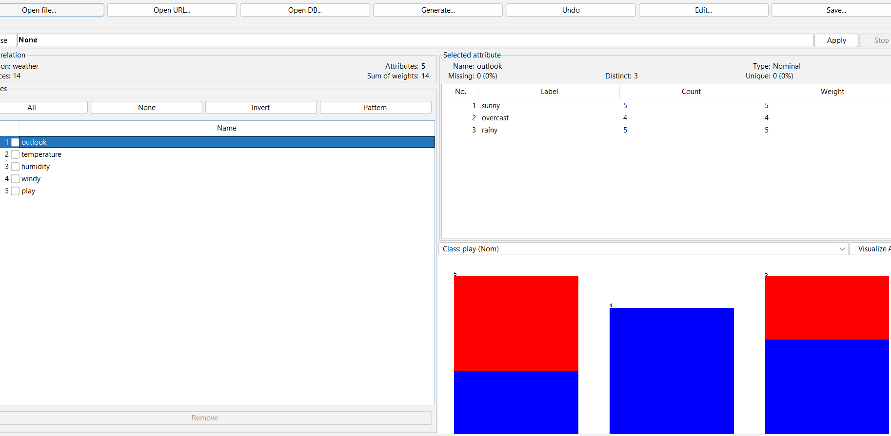

2. K-MEANS CLUSTERING BY WEKA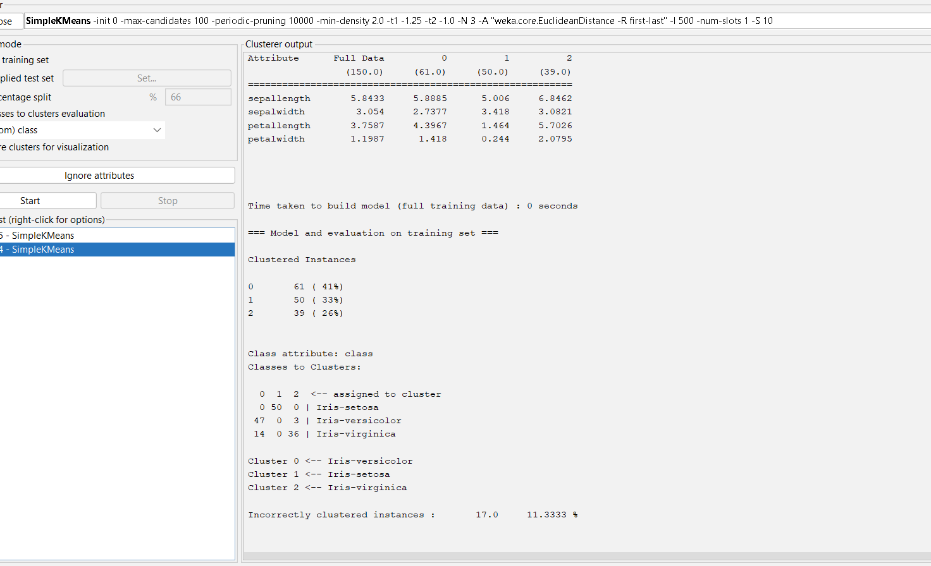

OUTPUT INFORMATION OF SIMPLE K MEANS CLUSTERING –CLUSTERER OUTPUT

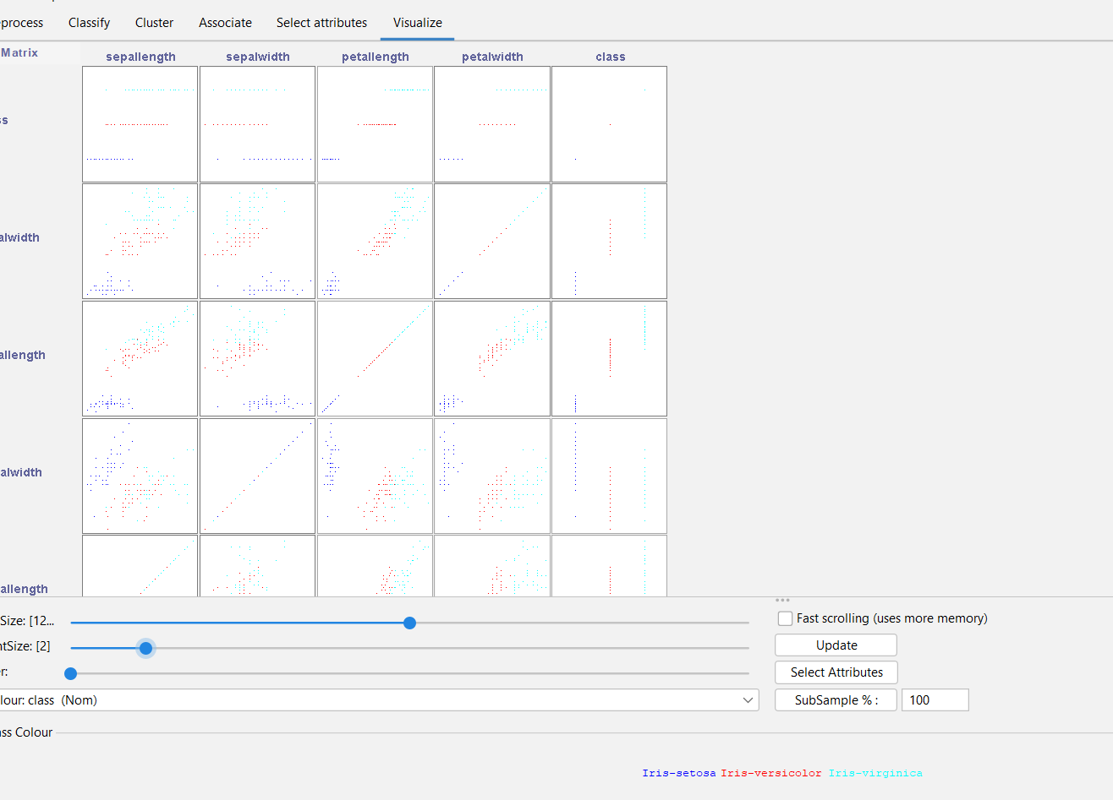

K MEANS CLUSTERING IN WEKAA USING IRIS INFORMATION – PLOTTING ..

3. DATA ANALYSIS BY EXPECTION MAXIMISATION ALGORITHM USING WEKA

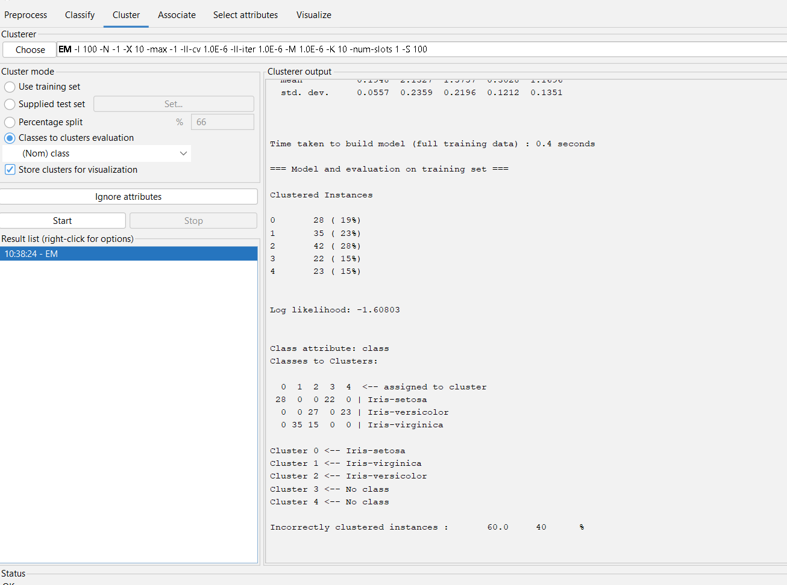

DATA ANALYSIS BY EXPECTATION MAXIMISATION ALGORITHM – OUTPUT INNFO OF IRIS

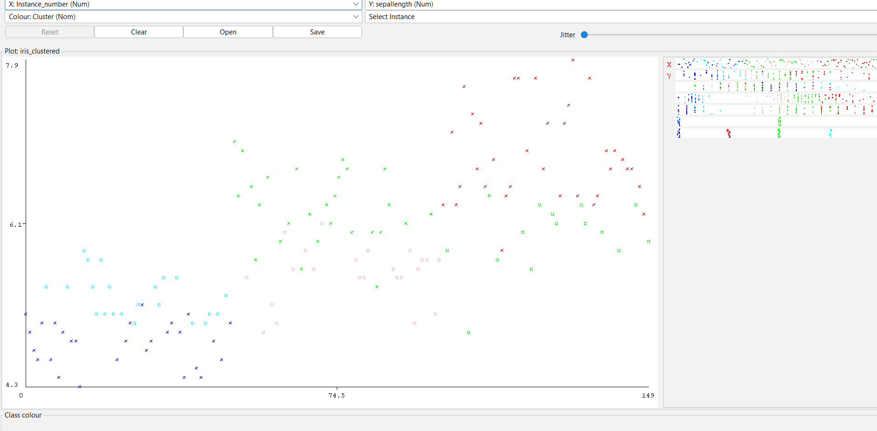

DATA ANALYSIS BY EXPECTATION MAXIMISATION ALGORITHM—PLOT DIAGRAM OF IRIS INFO

4.DATA ANALYSIS BY HIERARCHICAL CLUSTERING. IN WEKA

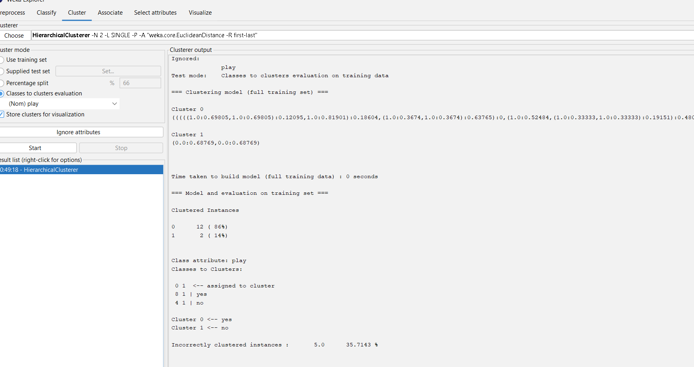

OUTPUT INFORMATION

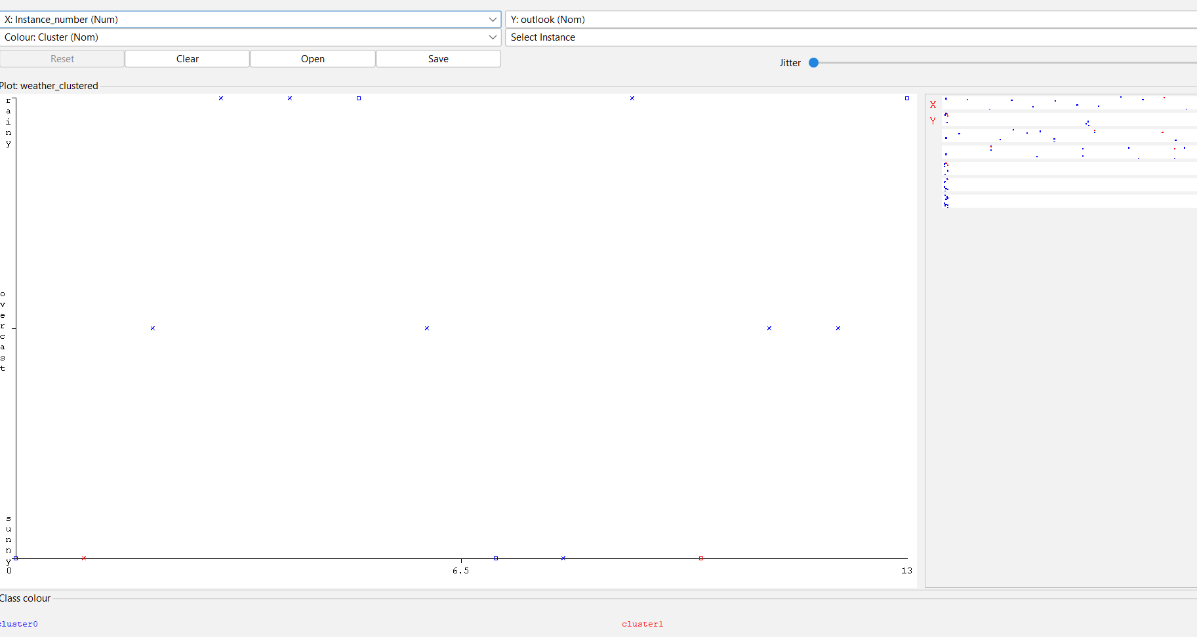

VISUALISING THE PLOT GRAPH OF CLUSTER ASSIGNMENTS

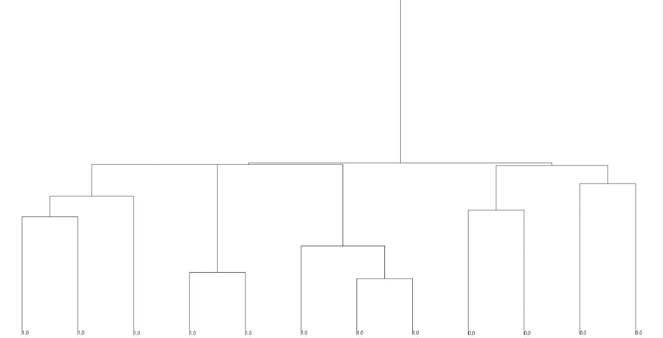

HIERARCHICAL TREE FOR DATA ANALYSIS.

5.KNOWLEDGE MINING FOR ASSOCIATION RULES USING WEKA

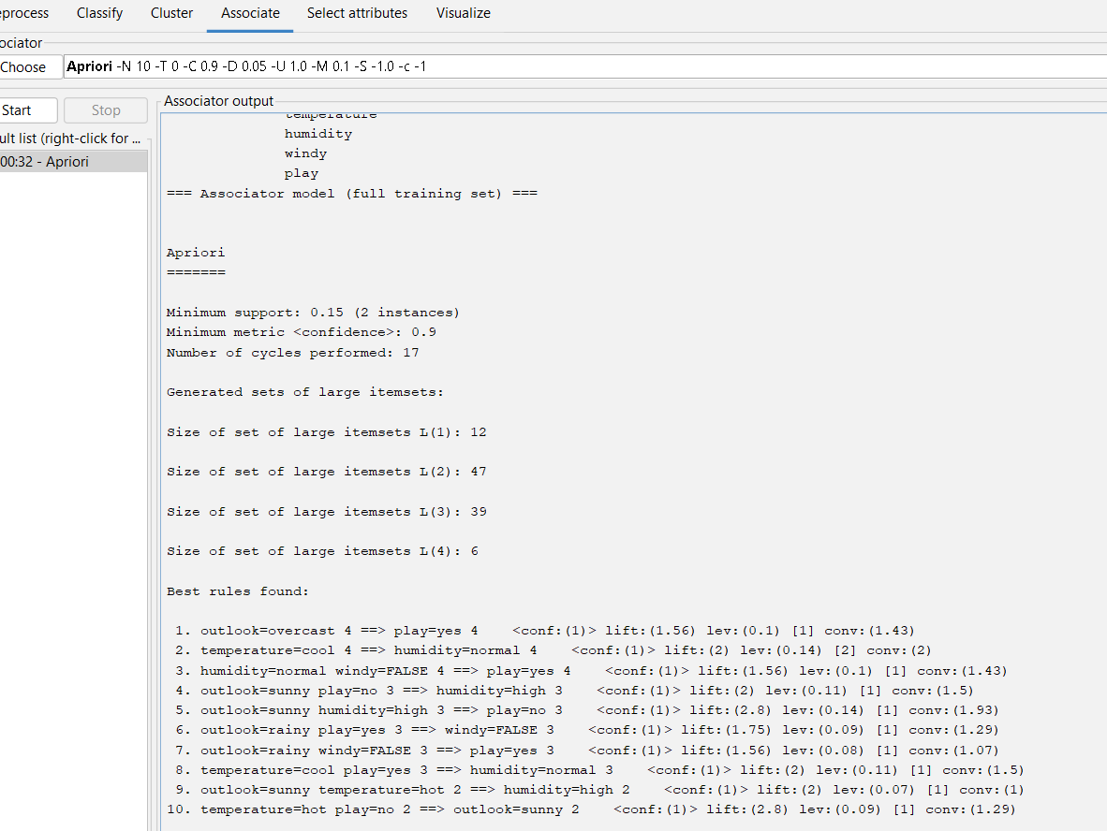

OUTPUT INFORMATION USING WEATHER NOMINAL DATA

6. EVALUATING THE ACCURACY OF THE CLASSIFIERS

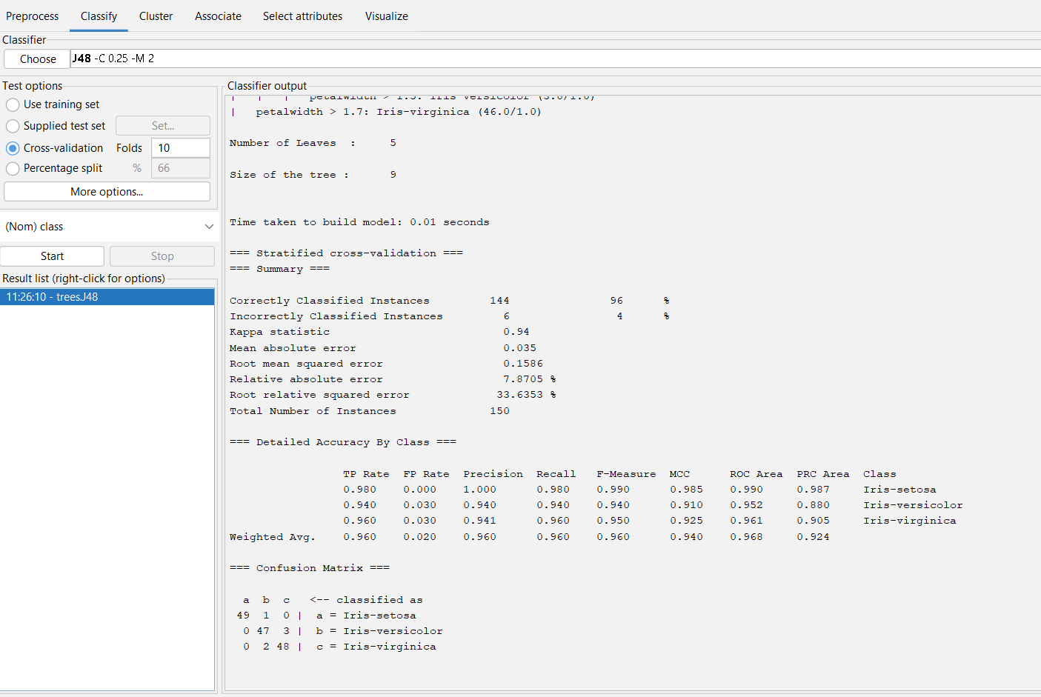

OUTPUT INFORMAATION OF IRIS IN ACCURACY FINDING.

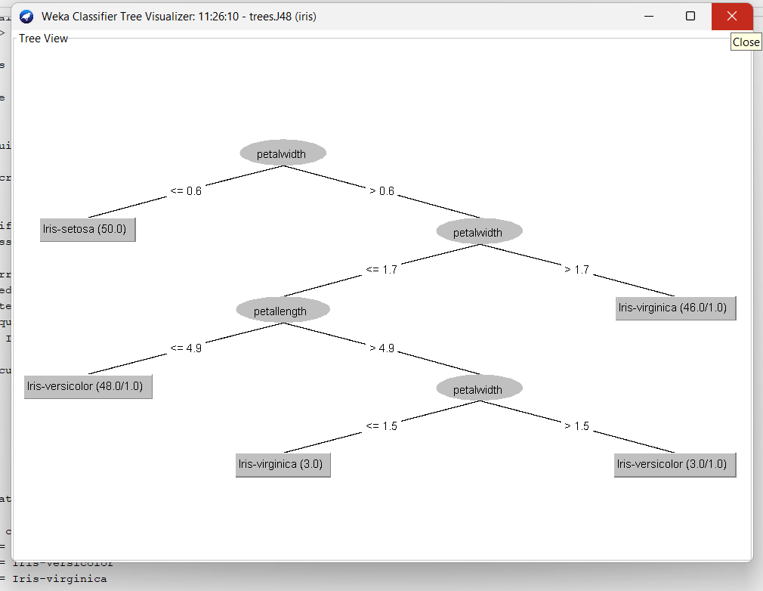

TREE DIAGRAM OF ACCURACY WITH IRIS INFO IN WEKA

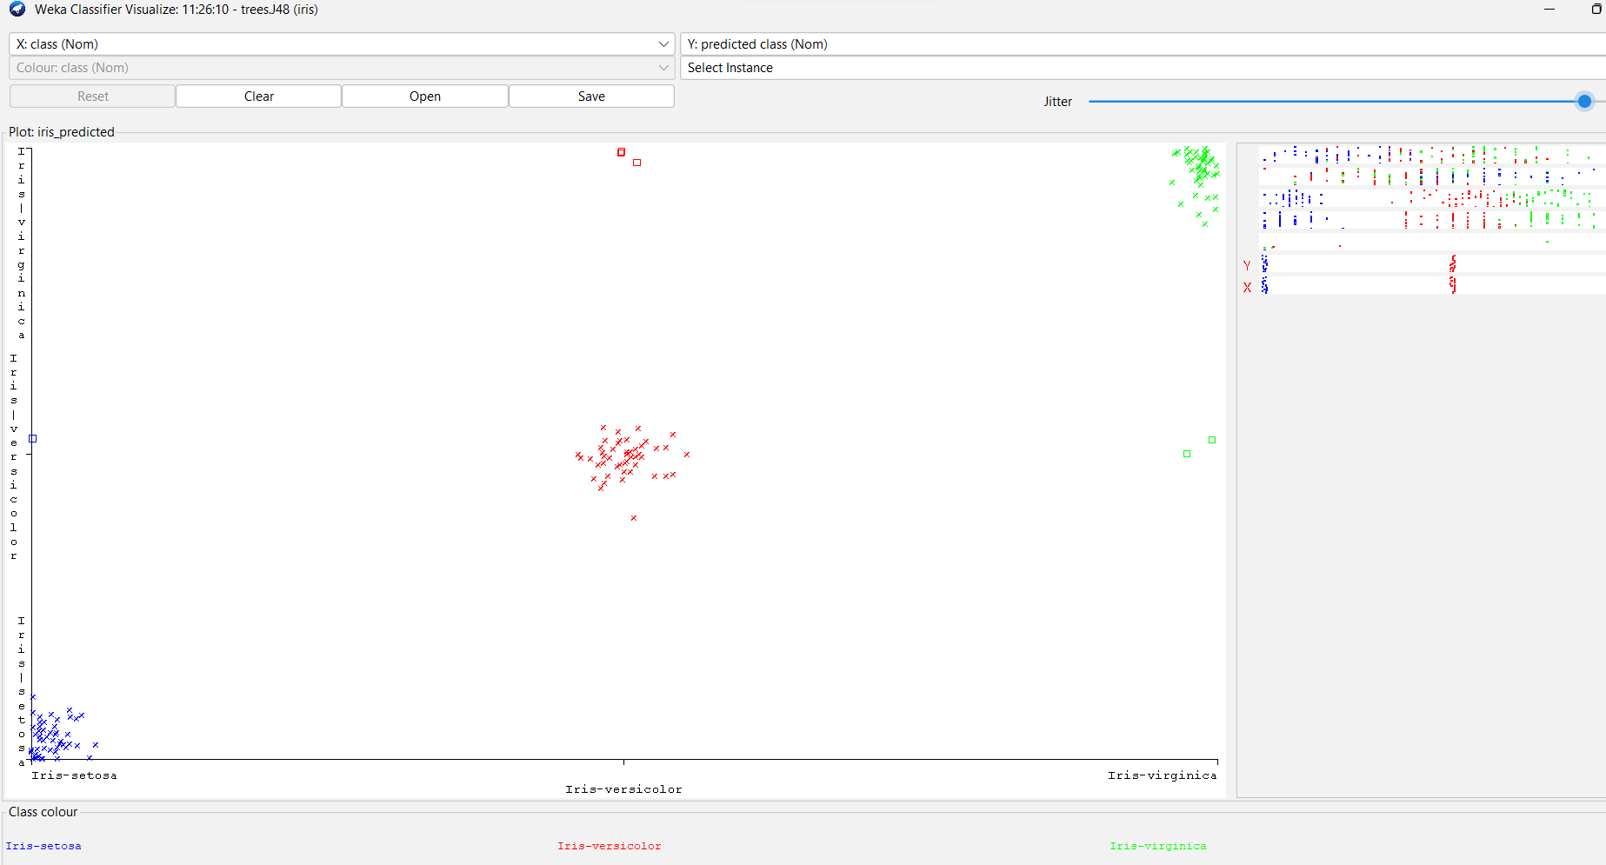

ERROR ACCURACY RATE OF IRIS IN WEKA.